**ASP.NET Core App Development**

**Using Grunt**

**Lab Exercise**

Table of Contents

1 Introduction to Grunt 3

2 Preparing the application 3

3 Configuring NPM 5

4 Configuring Grunt 6

5 The "all" Task 11

6 Watching for changes 11

7 Binding to Visual Studio Events 12

8 Summary 13

# Introduction to Grunt

Grunt is a JavaScript task runner that automates script minification, TypeScript compilation, code quality “lint” tools, CSS pre-processors, and just about any repetitive chore that needs doing to support client development. Grunt is fully supported in Visual Studio, though the ASP.NET project templates use Gulp by default

**Sections:**

* Preparing the application
* Configuring NPM
* Configuring Grunt
* Watching for changes
* Binding to Visual Studio Events
* Summary

This example uses an empty ASP.NET Core project as its starting point, to show how to automate the client build process from scratch.

The finished example cleans the target deployment directory, combines JavaScript files, checks code quality, condenses JavaScript file content and deploys to the root of your web application. We will use the following packages:

* **grunt**: The Grunt task runner package.
* **grunt-contrib-clean**: A plugin that removes files or directories.
* **grunt-contrib-jshint**: A plugin that reviews JavaScript code quality.
* **grunt-contrib-concat**: A plugin that joins files into a single file.
* **grunt-contrib-uglify**: A plugin that minifies JavaScript to reduce size.
* **grunt-contrib-watch**: A plugin that watches file activity.

# Preparing the application

To begin, set up a new empty web application and add TypeScript example files. TypeScript files are automatically compiled into JavaScript using default Visual Studio settings and will be our raw material to process using Grunt.

1. In Visual Studio, create a new ASP.NET Web Application.
2. In the **New ASP.NET Project** dialog, select the ASP.NET Core **Empty** template and click the OK button.
3. In the Solution Explorer, review the project structure. The \src folder includes empty wwwrootand Dependencies nodes.

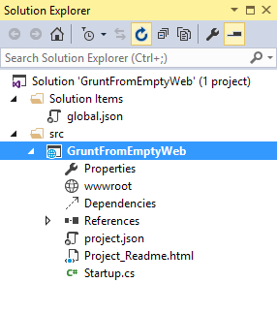

1. Add a new folder named TypeScript to your project directory.
2. Before adding any files, let’s make sure that Visual Studio has the option ‘compile on save’ for TypeScript files checked. *Tools > Options > Text Editor > Typescript > Project*

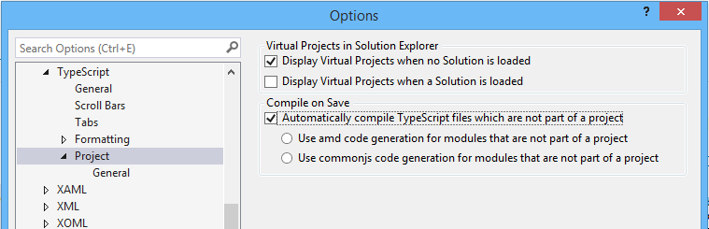

1. Right-click the TypeScript directory and select **Add > New Item** from the context menu. Select the **JavaScript file** item and name the file **Tastes.ts** (note the *.ts extension). Copy the line of TypeScript code below into the file (when you save, a new Tastes.js file will appear with the JavaScript source).

**enum** Tastes { Sweet, Sour, Salty, Bitter }

1. Add a second file to the **TypeScript** directory and name it Food.ts. Copy the code below into the file.

**class** Food {

constructor(name**:** string, calories**:** number) {

**this**._name **=** name;

**this**._calories **=** calories;

}

**private** _name**:** string;

get Name() {

**return** **this**._name;

}

**private** _calories**:** number;

get Calories() {

**return** **this**._calories;

}

**private** _taste**:** Tastes;

get Taste()**:** Tastes { **return** **this**._taste }

set Taste(value**:** Tastes) {

**this**._taste **=** value;

}

}

# Configuring NPM

Next, configure NPM to download grunt and grunt-tasks.

1. In the Solution Explorer, right-click the project and select **Add > New Item** from the context menu. Select the **NPM configuration file** item, leave the default name, package.json, and click the **Add** button.
2. In the package.json file, inside the devDependencies object braces, enter “grunt”. Select gruntfrom the Intellisense list and press the Enter key. Visual Studio will quote the grunt package name, and add a colon. To the right of the colon, select the latest stable version of the package from the top of the Intellisense list (press Ctrl-Space if Intellisense does not appear).

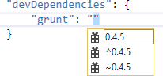

**Note**

NPM uses semantic versioning to organize dependencies. Semantic versioning, also known as SemVer, identifies packages with the numbering scheme <major>.<minor>.<patch>. Intellisense simplifies semantic versioning by showing only a few common choices. The top item in the Intellisense list (0.4.5 in the example above) is considered the latest stable version of the package. The caret (^) symbol matches the most recent major version and the tilde (~) matches the most recent minor version. See the NPM semver version parser reference as a guide to the full expressivity that SemVer provides.

1. Add more dependencies to load grunt-contrib* packages for *clean, jshint, concat, uglify and watch* as shown in the example below. The versions do not need to match the example.

"devDependencies"**:** {

"grunt"**:** "0.4.5",

"grunt-contrib-clean"**:** "0.6.0",

"grunt-contrib-jshint"**:** "0.11.0",

"grunt-contrib-concat"**:** "0.5.1",

"grunt-contrib-uglify"**:** "0.8.0",

"grunt-contrib-watch"**:** "0.6.1"

}

1. Save the package.json file.

The packages for each devDependencies item will download, along with any files that each package requires. You can find the package files in the node_modules directory by enabling the**Show All Files** button in the Solution Explorer.

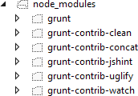

**Note**

If you need to, you can manually restore dependencies in Solution Explorer by right-clicking onDependencies\NPM and selecting the **Restore Packages** menu option.

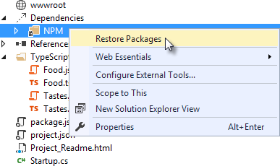

# Configuring Grunt

Grunt is configured using a manifest named Gruntfile.js that defines, loads and registers tasks that can be run manually or configured to run automatically based on events in Visual Studio.

1. Right-click the project and select **Add > New Item**. Select the **Grunt Configuration file** option, leave the default name, Gruntfile.js, and click the **Add** button.

The initial code includes a module definition and the grunt.initConfig() method. The initConfig()is used to set options for each package, and the remainder of the module will load and register tasks.

module.exports **=** **function** (grunt) {

grunt.initConfig({

});

};

1. Inside the initConfig() method, add options for the clean task as shown in the example Gruntfile.js below. The clean task accepts an array of directory strings. This task removes files from wwwroot/lib and removes the entire /temp directory.

module.exports **=** **function** (grunt) {

grunt.initConfig({

clean**:** ["wwwroot/lib/*", "temp/"],

});

};

1. Below the initConfig() method, add a call to grunt.loadNpmTasks(). This will make the task runnable from Visual Studio.

grunt.loadNpmTasks("grunt-contrib-clean");

1. Save Gruntfile.js. The file should look something like the screenshot below.

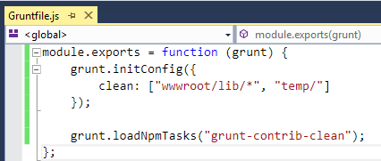

1. Right-click Gruntfile.js and select **Task Runner Explorer** from the context menu. The Task Runner Explorer window will open.

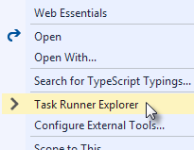

1. Verify that clean shows under **Tasks** in the Task Runner Explorer.

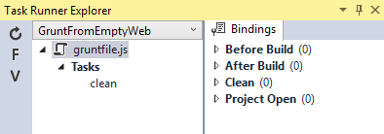

1. Right-click the clean task and select **Run** from the context menu. A command window displays progress of the task.

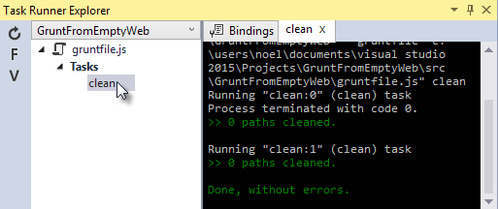

**Note**

There are no files or directories to clean yet. If you like, you can manually create them in the Solution Explorer and then run the clean task as a test.

1. In the initConfig() method, add an entry for concat using the code below.

The src property array lists files to combine, in the order that they should be combined. Thedest property assigns the path to the combined file that is produced.

concat**:** {

all**:** {

src**:** ['TypeScript/Tastes.js', 'TypeScript/Food.js'],

dest**:** 'temp/combined.js'

}

},

**Note**

The all property in the code above is the name of a target. Targets are used in some Grunt tasks to allow multiple build environments. You can view the built-in targets using Intellisense or assign your own.

1. Add the jshint task using the code below.

The jshint code-quality utility is run against every JavaScript file found in the temp directory.

jshint**:** {

files**:** ['temp/*.js'],

options**:** {

'-W069'**:** **false**,

}

},

**Note**

The option “-W069” is an error produced by jshint when JavaScript uses bracket syntax to assign a property instead of dot notation, i.e. Tastes["Sweet"] instead of Tastes.Sweet. The option turns off the warning to allow the rest of the process to continue.

1. Add the uglify task using the code below.

The task minifies the combined.js file found in the temp directory and creates the result file in wwwroot/lib following the standard naming convention <file name>.min.js.

uglify**:** {

all**:** {

src**:** ['temp/combined.js'],

dest**:** 'wwwroot/lib/combined.min.js'

}

},

1. Under the call grunt.loadNpmTasks() that loads grunt-contrib-clean, include the same call for jshint, concat and uglify using the code below.

grunt.loadNpmTasks('grunt-contrib-jshint');

grunt.loadNpmTasks('grunt-contrib-concat');

grunt.loadNpmTasks('grunt-contrib-uglify');

1. Save Gruntfile.js. The file should look something like the example below.

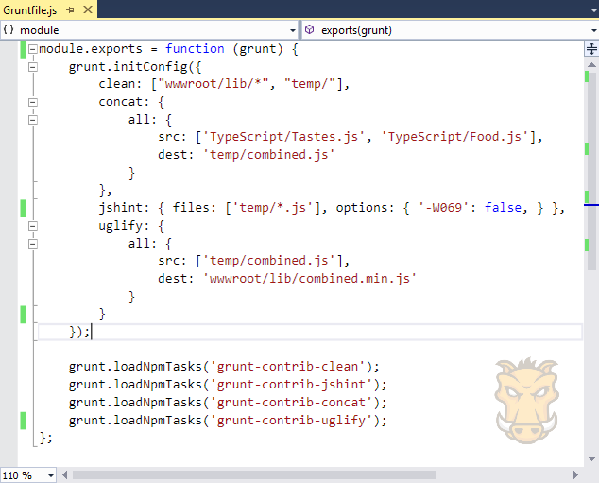

1. Notice that the Task Runner Explorer Tasks list includes clean, concat, jshint and uglifytasks. Run each task in order and observe the results in Solution Explorer. Each task should run without errors.

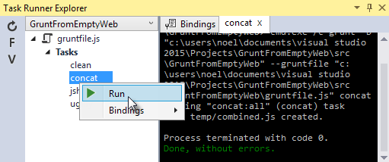

The concat task creates a new combined.js file and places it into the temp directory. The jshint task simply runs and doesn’t produce output. The uglify task creates a new combined.min.js file and places it into wwwroot/lib. On completion, the solution should look something like the screenshot below:

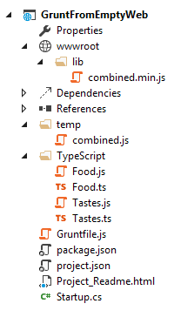

**Note**

For more information on the options for each package, visit https://www.npmjs.com/ and lookup the package name in the search box on the main page. For example, you can look up the grunt-contrib-clean package to get a documentation link that explains all of its parameters.

# The "all" Task

Use the Grunt registerTask() method to run a series of tasks in a particular sequence. For example, to run the example steps above in the order clean -> concat -> jshint -> uglify, add the code below to the module. The code should be added to the same level as the loadNpmTasks() calls, outside initConfig.

grunt.registerTask("all", ['clean', 'concat', 'jshint', 'uglify']);

The new task shows up in Task Runner Explorer under Alias Tasks. You can right-click and run it just as you would other tasks. The all task will run clean, concat, jshint and uglify, in order.

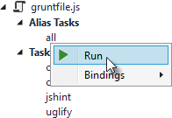

# Watching for changes

A watch task keeps an eye on files and directories. The watch triggers tasks automatically if it detects changes. Add the code below to initConfig to watch for changes to *.js files in the TypeScript directory. If a JavaScript file is changed, watch will run the all task.

watch**:** {

files**:** ["TypeScript/*.js"],

tasks**:** ["all"]

}

Add a call to loadNpmTasks() to show the watch task in Task Runner Explorer.

grunt.loadNpmTasks('grunt-contrib-watch');

Right-click the watch task in Task Runner Explorer and select Run from the context menu. The command window that shows the watch task running will display a “Waiting…” message. Open one of the TypeScript files, add a space, and then save the file. This will trigger the watch task and trigger the other tasks to run in order. The screenshot below shows a sample run.

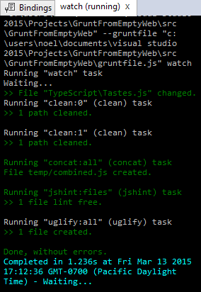

# Binding to Visual Studio Events

Unless you want to manually start your tasks every time you work in Visual Studio, you can bind tasks to **Before Build**, **After Build**, **Clean**, and **Project Open** events.

Let’s bind watch so that it runs every time Visual Studio opens. In Task Runner Explorer, right-click the watch task and select **Bindings > Project Open** from the context menu.

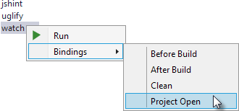

Unload and reload the project. When the project loads again, the watch task will start running automatically.

# Summary

Grunt is a powerful task runner that can be used to automate most client-build tasks. Grunt leverages NPM to deliver its packages, and features tooling integration with Visual Studio. Visual Studio’s Task Runner Explorer detects changes to configuration files and provides a convenient interface to run tasks, view running tasks, and bind tasks to Visual Studio events.